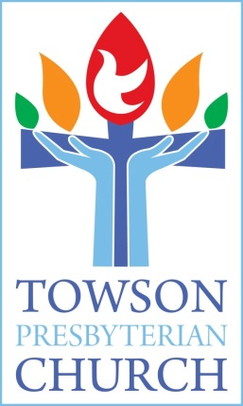

Adult Spiritual Formation
&
Small Group Schedule

Winter - 2020

Inclusive - Curious - Compassionate - Courageous

400 W. Chesapeake Ave.
Towson, MD 21204
410-823-6500
www.towsonpres.org

Winter Small Groups
Friendship / Fellowship Groups

Diner’s Club
- Time & Place: TBA
- Purpose: Diner's Club is a small group of 10
- members/friends enjoying a potluck dinner together once a month in January, February and March. Meet new people, enjoy fellowship and have fun.
- Leaders: Phyllis Gray and Eric Hauer

Winter Hiking
- Time & Place: Every other weekend starting February 1 and ends March 28, 9:00 a.m. – 10:30.
- Purpose: Come outdoors and enjoy God's creation this winter. Hikes are no more than 2 hours in length. Locations generally within 10-30 minutes of TPC and vary from easy strolls (suitable for families ages 5+) to strenuous (active adults/teens). Carpools available at TPC at 8:30 a.m.
- Leader: Jen Bolster

Tea Tasting
- Time & Place: Meets Thursday Jan 23, 30 and February 6, 13, 20, 27 from 1:00-1:50 p.m. at TPC in The Nook.
- Purpose: Bring your favorite teacup, try new teas, listen to a short reading and build friendships.
- Leader: Karen Cicmanec

Meet to Eat
- Time & Place: Meets three Saturdays in February-April at 6:30 p.m. Locations TBD.
- Purpose: Designed for singles who want to enjoy a dining experience with other church members and meet at a local restaurant. Restaurants will be modestly priced and offer a variety of cuisine.
- Leader: Karen Drake

Study Groups
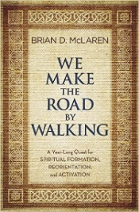
“We Make the Road By Walking” in Lent
- Time & Place: Groups meet Sunday and throughout the week at both TPC and various members’ homes.
- Purpose: Explore Brian McLaren’s Lenten reflections in “We Make the Road By Walking.” Come having read or not read the chapter. Discussion groups meet 4-5 times in March to discuss a chapter a week.
- Leaders: Chris & Bonnie Britt, Phyllis Gray & Bob Bickel, Jim Kuhlman, Ro Nicolosi, Patty O’Brien, and Joan Pugh.

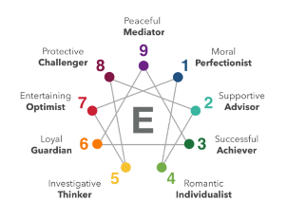
More About You: Intro to the Enneagram
- Time & Place: Sunday February 2, 16, 23 and March 1 in the TPC Chapel from 11:30-12:30.
- Purpose: The Enneagram is a pathway to growth based on personality types and their spiritual foundations. Learn more about each type’s ‘core blessing’ on your journey toward a better you.
- Cost: $10.00/person
- Leader: Jimmy Carter and Enneagram Coach Bev Gorman

Mission Groups

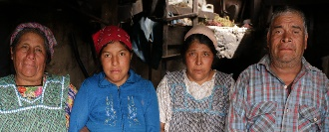
Immigration Study: “The Genesis of Exodus”
- Time & Place: Sunday February 2, 16 and 23 in the TPC Youth Room from 11:30-12:30.
- Purpose: Based on the PC(USA)’s “Genesis of Exodus” documentary, deepen your understanding and explore the root causes of Central American migration.
- Leader: Corky Shaw

Gun Violence and What the Faith Community Can Do About It
- Time & Place: Sunday, February 16 and 23 in the TPC Library from 11:15-12:30.
- Purpose: Using the PC(USA)’s “Standing on Holy Ground” webinar series, explore our denomination’s theology around our gun violence policies and steps churches can take to address it.
- Leader: Ginny Probasco

Upcoming Spring Small Groups
Running
- Meets two Saturdays a month in April, May and June at 8:00 a.m. at Loch Raven Reservoir
Biking
- Meets two Sundays a month in April and May from 2-4 p.m. at the NCR Trail’s Paper Mill Rd parking lot., 1 mile off of York Rd.
Golf
- One Friday or Monday per month in April, May and June at a nearby golf course.
Spiritual Friendships
- Meets for four Sundays in May and explores what it looks like to be a modern-day disciple, helping others along their way.

Additional Offerings

Faith @ Home
- Explore faith outside of Sunday morning with spiritual reading, podcasts, apps and spiritual practices at towsonpres.org

Skype Conversation with “We Make the Road By Walking” author Brian
McLaren on Sunday, March 29 during 10:00 a.m. worship

Joel & Rob’s Podcast
- Listen on the go (at the gym, taking a walk, washing the dishes) as Joel and Rob explore a chapter of “We Make the Road By Walking” and their own ongoing faith formation.

Circle 13
- Open to all women, this group meets on the second Monday of the month from 7-9 p.m. in various members’ homes for fellowship and study. For more information contact Dotsie Bregel at dbregel@gmail.com

“Mary, Martha and Me”
- An opportunity for older, single women to eat, talk and share activities together with other women in a similar stage Meets on the first Monday of each month from 4:30-8:00 p.m. For more information contact Karen Williams at rewdmd@gmail.com.

Men’s Group
- Meets on the first Monday night of the month. Gather in the Library over drinks (beer, soda, and more) to build relationships and share some of what’s in our minds and on our hearts. For more information contact Pastor Rob or Pastor Joel.

What Does It Mean to be Inclusive?
- Coming on Sunday May 17 and led by David Jackson, explore why “inclusivity” is so hard and how can we better pursue it.

Parents Night Out
- Meets three times a year for food and fellowship. Childcare is provided. For more information contact Kimberly Light at light.kimberly@yahoo.com.

Prayer Shawl
- Meets on the third and fourth Tuesday in the Nook at 1:00 p.m. Shawls and lap blankets are made and given to those experiencing illness and loss. For more information contact Lorene LaBerge at sing2melor@gmail.com

Men’s Breakfast
- Meets on the third Thursday of the month at Towson Diner at 9 a.m. for food, friendship and conversation. For more information contact Rev. Strom.

