*Invitation to Confess Jenness Hall
*Litany of Confession
Leader: Merciful God, we live in a society that focuses on gathering things.
People: We collect, store, gather items, gadgets, even people.
Leader: We focus our energies on our collections.
We save for them;
we make room for them;
we trust in them.
People: And yet we give so little of ourselves
to those who are in pain;
to those who have little or nothing;
to those for whom life has been a constant struggle.
Leader: We believe our security comes from possessions,
while assuming it is your job to care for the least and last.
People: Forgive us. Turn us around.
Help us see all the ways our wealth,
both of substance and spirit,
can be used to spread healing and hope.
Remind us of our call to live as ministers of Jesus Christ,
who shared the gifts of your kingdom with each and all.

~ silent reflection and confession ~

*Assurance of Grace
Leader: Family of God, rejoice!
People: In Jesus Christ, we are forgiven
and blessed with new life!

*Response to Grace
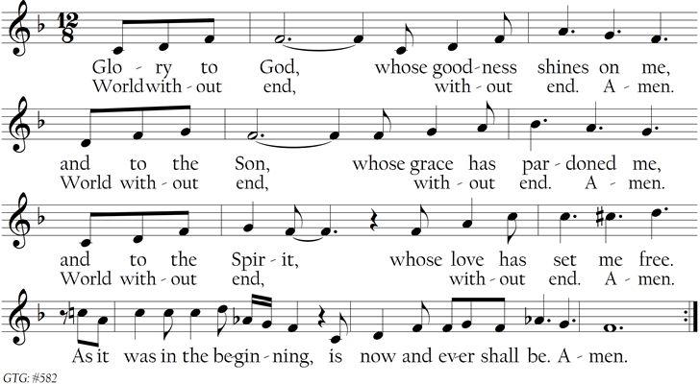

*Passing of the Peace
Leader: Let us share the peace that fosters justice and kindness.
May the peace of Christ be with you.
People: And also with you.

~ All are invited to share the “peace” of Christ with one another ~

~ Children are invited to come forward ~

Children’s Message

~ Children through Grade 5 are invited to return to their seats or gather at the “Worship Tables”
to work on a special worship craft ~
Proclaim God’s Word

Prayer for Illumination Judith Rietz
Scripture Reading
Luke 12: 13-21 (Pew Bible p. 74, N. T.)
Leader: For the Word of God in Scripture,
For the Word of God among us,
For the Word of God within us,
People: Thanks be to God!

Sermon “The Unholy Trinity”

Respond in Thanks & Faith

*Hymn #692 | “Spirit, Open My Heart” | Wild Mountain Thyme
(Please see insert)
Call to Commitment
Offertory (10:00) Theme from Schindler’s List John Williams
Colynn Furgason, clarinet

*Doxology
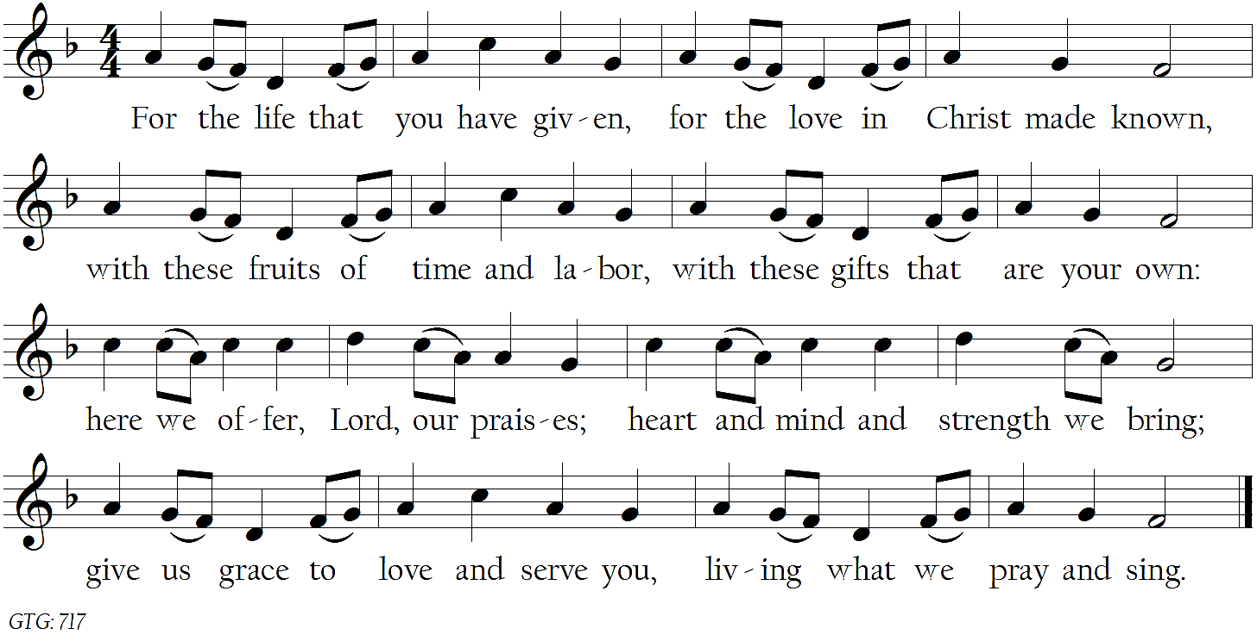

*Prayer of Dedication
Leader: We give in grateful response to all you have given us, O God.
People: In the ways of your kingdom, Lord,
we measure our wealth not by what we have,
but what we invest in those around us,
that hope, peace, and love might spread.

The Sacrament of the Lord’s Supper
Invitation to the Table
The Great Prayer of Thanksgiving
Leader: May God Almighty—the God of unending hope—be with you.
People: And also with you.
Leader: Lift up your hearts.
People: We lift them to God.
Leader: Let us give thanks to the God we love.
People: We freely give God thanks and praise.

(The prayer continues…)
The Communion of the People
Jesus welcomes each and all to his table. All who desire may
approach the Communion servers through the center aisle to take a piece of bread and dip it into the cup (containing unfermented grape juice) before consuming it. Gluten-free wafers are available in a bowl on the communion table. Anyone wishing to remain seated and be served from a tray may so indicate to a server.
Prayer of Response
O God, send us out from Christ’s table
to answer his summons into new life
and to follow him with joy and gladness.
Set our feet in his way,
that our lives may be signs of his life
and all we do may show forth his love. Amen.

*Hymn #515 | “I Come with Joy” | Dove of Peace
(Please see insert)
*Benediction

Postlude Down by the Riverside arr. Daniel Kallman

*Worshippers are invited to stand as able.
**Large print bulletins with hymns and hearing assistance devices are available;
please ask a deacon (with a red nametag) for assistance.

The Towson Presbyterian Church
Inclusive ~ Curious ~ Compassionate ~ Courageous

400 W. Chesapeake Ave., Towson, Maryland 21204

www.towsonpres.org 410.823.6500 tpc@towsonpres.org

Ministers All the members of the church
Pastor, Senior The Rev. Rob Carter
Pastor, Associate The Rev. Joel Strom
Director of Music and Organist Stephen Harouff
Director of Children and Family Ministry Jenness Hall
Administrative & Communications Coordinator Tara Flynn Runge
Business Administrator Kathryn Bojanowski
Director, Towson Presbyterian Preschool Leslie Foretich
Sexton Walter Austin
Pastor Emeritus The Rev. Dr. George Gray Toole

Our Mission:
Towson Presbyterian Church is an inclusive community of faith
growing as disciples of Christ

TPC is a PC(USA) Earth Care Congregation,
and a member of the Covenant Network (striving for a fully inclusive church).

Let’s connect:
Facebook @TowsonPres || Twitter @TowsonPres || Instagram @TowsonPres

New Here? Welcome—just as you are.

We’re grateful you’re here. Please note your name and email address in the sign-in pads on the inside of each pew. Please also visit us at www.towsonpres.org to learn more about our faith community. You’re invited to participate in any church events or programs.
For your worshipping comfort, large-print bulletins and hearing assistance devices are available at the rear of the sanctuary. Deacons (wearing red nametags) are also located throughout the building to offer any assistance you might desire.
While children are whole-heartedly welcome within worship, our professionally-staffed nursery is available. Please see a deacon for assistance.
Able to stay for refreshments? Please join us at “Coffee Hour,” located in our Hall on the bottom level (next to the parking lot).

Please pray for: Bob Adams, Davis Barkley (Roxanne Maffitt Harvey’s grandson), Mary Grace Byrne, Cindy Cole (JoAnn Brooks’ sister), Barbara Davis, Elsie DeGarmo Smith, Kathleen Flynn (Tara’s sister), Angie Hodge, Mike Just, Jack LaBerge (Chuck’s father), Kelsen LaBerge, Julie Mertus, Jane Messimer, and Carol Morton. Names remain on prayer list for four weeks, unless otherwise requested.

The flowers in the sanctuary are given by the Good Family in loving memory of George Good, Sr. and in celebration of 10 years of the Intergenerational Garden and in gratitude for all of the many volunteers that make the IGG thrive.

The votive on the communion table marks the first anniversary of the death of Ilein Pearce (8/7).

Today at TPC

Assisting in Worship today: Sandi Burt, Alex Foley, Mike Just, Pat Keller, Kim Labrique, Viraj Mehta, Ro Nicolosi, and Patty O’Brien.

Sunday, August 4
9:15 a.m. Nursery Care for Infants – age 3 – Noah’s Nursery
9:30 a.m. Worship Service – THOMPSON HALL
10:30 a.m. Music Literacy – Choir Room
Coffee Hour – Thompson Hall
11:30 a.m. SCL – Thompson Hall
Electronic Giving: text “CheerfulGiver” (all one word/no spaces) to 73256 or scan the QR Code to the right.

All God’s People

Worship in Thompson Hall || Sunday August 11 || We worship amid a more casual atmosphere in which worshippers can sip refreshments, and children will worship with us at special children’s worship tables.

Schedules to note:
- Rev. Carter will be on vacation August 5 – 18.
- Tara Runge will be on vacation August 12 – 14
- Rev. Strom will be on vacation August 12 – 25.
Hymn Sings || Throughout the summer, Stephen will lead a hymn sing to begin worship each Sunday this summer. Send your requests to sharouff@towsonpres.org.

ACTC School Supplies Drive || A list of requested items can be found at www.actconline.info/Events.php or at ACTC’s Facebook page. Donations are due to ACTC by August 14.

Have an idea for a Small Group? || Do you have an idea for a Fellowship, Study or Mission small group that you’d like to bring to TPC? Reach out to Pastor Joel at jstrom@towsonpres.org.

Small Group || Fantasy Football || TPC's first-ever fantasy football Small Group is forming for the coming season. Registration is limited to the first 12 people to sign up by August 28. Register at towsonpres.org and contact Kevin McKenna at kevin.mckenna6@yahoo.com for more info.

Summer Choir on August 25th || Come one, come all || Everyone is invited to meet in the choir room at 8:45 to prepare an easy anthem for worship.

Grow in Music Literacy || Sundays thru – August 25 || Join Stephen for 15 minutes in the choir room each Sunday after worship to learn some fundamentals of music reading. All ages!!

Church School Teacher Training || Tuesday, August 27th & Wednesday August 28th || 7:00-8:30 pm || Library || Please choose one to attend.

Youth Ministry

ACTC & Dinner in Towson || Middle School || Tuesday, August 6 6-8 p.m. || Meet at TPC and walk to ACTC for a service project. || Dinner to follow in downtown Towson. Meet back at TPC at 8:00.

TPC This Week

Tuesday, August 6
10:30 a.m. Staff Meeting – Nook
6:00 p.m. MS Youth ACTC & Dinner
Wednesday August 7
7:00 p.m. Adult Spiritual Formation – Library
C.O.R.E. – Conference Room
Sunday, August 11
9:15 a.m. Nursery Care for Infants – age 3 – Noah’s Nursery
9:30 a.m. Worship Service – THOMPSON HALL
10:30 a.m. Music Literacy – Choir Room
Coffee Hour – Thompson Hall
11:30 a.m. SCL – Thompson Hall

The Service of the Lord’s Day

21st Sunday of Ordinary Time

Aug. 4, 2019 || 9:30 a.m.

Assemble in God’s Name

We joyfully welcome you to worship this morning!
All are invited to use the Prayer as a time of silent preparation.

Prayerful Reflection by Katherine Hawker
Masters,
two and more,
competing for our money,
clamoring for our time,
creating chaos in our lives.

Master,
one God,
quiet us and draw us near.

Prelude Hymn Sing

Welcome Rev. Rob Carter

*Call to Worship Rev. Joel Strom
Leader: Let us gather before God, people of the covenant.
Listen for God’s Word.
People: God has gathered us here in love,
that we might explore more of whose we are.
Leader: God’s Word is broader than our perspectives,
and greater than our assumptions and opinions.
People: God calls us to work for love and justice,
rather than ourselves.
God calls us to life in all its fullness,
rather than life as we would live it.
Leader: Prepare to be equipped!
People: We rejoice in the worship of God!

*Hymn #411 | “God Is Here Today” | Dios Esta Aqui
God is here today;
as certain as the air I breathe,
as certain as the morning sun that rises,
as certain when I sing you’ll hear my song.

